

XYZ COMPANY

Detailed Test Plan – Urban Ladder Website

XYZ System

This copy printed on: November 29,2021

Document Last Modification date: December 15, 2021

Version: 1

Status: <Incubation>

Revision: 1

Document Owner: Team 1: SDET Java+ Python

Document Author: Team 1: SDET Java+ Python

Document Reviewer: <Manasvi Manjula>

Abstract

This document provides an overview of the project and the product test strategy, a list of

testing deliverables and plan for development

*Private & Confidential*

**VERSION HISTORY**

|  |  |  |  |  |  |
| --- | --- | --- | --- | --- | --- |
| **Version #** | **Write by** | **Revision Date** | **Approved By** | **Approval Date** | **Outline** |
| 1.0 | *Team 1* |  |  |  |  |
|  |  |  |  |  |  |
|  |  |  |  |  |  |

**TABLE OF CONTENTS**

INTRODUCTION 4

1. TEST STRATEGY 4
   1. Test Type 5
   2. Scope of Testing 4
      1. Feature to be tested 4
      2. Feature not to be tested 5
   3. Risk and Issues 5
   4. Test Logistics 6
      1. Who will test? 6
      2. When will test occur? 6
2. TEST OBJECTIVE 6
3. TEST CRITERIA 6
   1. Suspension Criteria 6
   2. Exit Criteria 6
4. RESOURCE PLANNING 6
   1. System Resource 6
   2. Human Resource 7
5. TEST ENVIRONMENT 7
6. SCHEDULE & ESTIMATION 8
   1. All project task and estimation 8
   2. Schedule to complete these tasks 9
7. TEST DELIVERABLES 9
   1. Before testing phase 9
   2. During the testing 9
   3. After the testing cycles is over 9

# INTRODUCTION

The Test Plan is designed to prescribe the scope, approach, resources, and schedule of all testing activities of the website urban ladder.

The plan identifies the items to be tested, the features to be tested, the types of testing to be performed, the personnel responsible for testing, the resources and schedule required to complete testing, and the risks associated with the plan.

# TEST STRATEGY

## Scope of Testing

* + 1. **Feature to be tested**

All the feature of websiteGuru99 Bank which were defined in software requirement [specs](https://docs.google.com/document/d/1rPW5DV82VJT6vtA1VDSrfxaCBuAduxW0zb1yfTh_VMk/edit?pli=1) are need to bested

|  |  |  |
| --- | --- | --- |
| **Module Name** | **Applicable Roles** | **Description** |
| **login** | Customer | **Customer:** A customer can login with valid credentials |
| **Very merry sale** | Customer | **Customer:** A customer can see information about living, offers stores, furniture’s |
| **Elements in very**  **Merry sale module** | Customer | **Customer:** A customer can select the element which he/she want to explore |
| **Button click** | Customer | **Customer:** during button click on each element customer will be abled to see the detailed information about the element |
| **Sorting based on brands** | Customer | **Customer:** A customer can sort the products according to his/her preferred brand |
| **Sorting based on color** | Customer | **Customer:** A customer can sort the products according to his/her preferred color |
|  |  |  |

## Feature not to be tested

These features are not be tested because they are not included in the software requirement specs

* + - * User Interfaces
      * Hardware Interfaces
      * Software Interfaces
      * Database logical
      * Communications Interfaces
      * Website Security and Performance

## Test Type

In the project Guru99 Bank, there’re 3 types of testing should be conducted.

* **Integration** Testing (Individual software modules are combined and tested as a group)
  + **System** Testing: Conducted on a **complete**, **integrated** system to evaluate the system's compliance with its specified requirements
  + **API testing:** Test all the APIs create for the software under tested

## Risk and Issues

|  |  |
| --- | --- |
| **Risk** | **Mitigation** |
| **Team member lack the required skills for website testing.** | Plan **training course** to skill up your members |
| **The project schedule is too tight; it's hard to complete this project on time** | Set **Test Priority** for each of the test activity. |
| **Test Manager has poor management skill** | Plan leadership training for manager |

|  |  |
| --- | --- |
| **A lack of cooperation negatively affects your employees' productivity** | **Encourage** each team member in his task, **and inspire** them to greater efforts. |
| **Wrong budget estimate and cost overruns** | Establish the scope before beginning work, pay a lot of attention to project planning and constantly track and measure the progress |

## Test Logistics

## Who will test?

The project will be tested by team 1

## When will test occur?

The tester will start the test execution when all the following inputs are ready

* Software is available for testing
* Test Specification is created
* Test Environment is built
* Enough human resource for testing

# TEST OBJECTIVE

The test objectives are to **verify** the Functionality of website urban ladder, the project should focus on testing the **module very marry sale** to **guarantee** all these operations can work **normally** in real business environment.

# TEST CRITERIA

## Suspension Criteria

If the team members report that there are **40%** of test cases **failed**, suspend testing until the development team fixes all the failed cases.

## Resumption criteria

Resumption will only occur when the problem(s) that caused the caused the suspension have been resolved

## Entry Criteria

Specifies the criteria that denote a **successful** completion of a test phase

* All test **hardware platforms** must have been **successfully** installed, configured, and functioning properly.
* All the necessary **documentation**, **design**, and requirements information should be available that will allow testers to operate the system and judge the correct behavior.
* All the standard software tools including the testing tools must have been successfully installed and functioning properly.
* Proper test data is available.
* The test environment such as, lab, hardware, software, and system administration support should be ready.

## Exit Criteria

Specifies the criteria that denote a **successful** completion of a test phase

* **Run** rate is mandatory to be **100%** unless a clear reason is given.
* **Pass** rate is **80%,** achieving the pass rate is **mandatory**.

# RESOURCE PLANNING

## System Resource

|  |  |  |
| --- | --- | --- |
| **No.** | **Resources** | **Descriptions** |
| **1.** | Testing tools | Protractor, selenium, testing, cucumber |
|  | Network | Setup a LAN Gigabit and 1 internet line with the speed at least 5 Mb/s |
|  | Computer | At least 4 computer run Windows 7, Ram 2GB, CPU 3.4GHZ |

## Human Resource

|  |  |  |
| --- | --- | --- |
| **No.** | **Member** | **Tasks** |
| **1.** | Test Manager | Manage the whole project Define project directions  Acquire appropriate resources |
| **2.** | Test | Identifying and describing appropriate test techniques/tools/automation architecture  Verify and assess the Test Approach  Execute the tests, Log results, Report the defects. Outsourced members |
| **3.** | Developer in Test | Implement the test cases, test program, test suite etc. |
| **4.** | Test Administrator | Builds up and ensures test environment and assets are managed and maintained  Support Tester to use the test environment for test execution |
| **5.** | SQA members | Take in charge of quality assurance  Check to confirm whether the testing process is meeting specified requirements |

# TEST ENVIRONMENT

The Test Environment should be setup as figure below

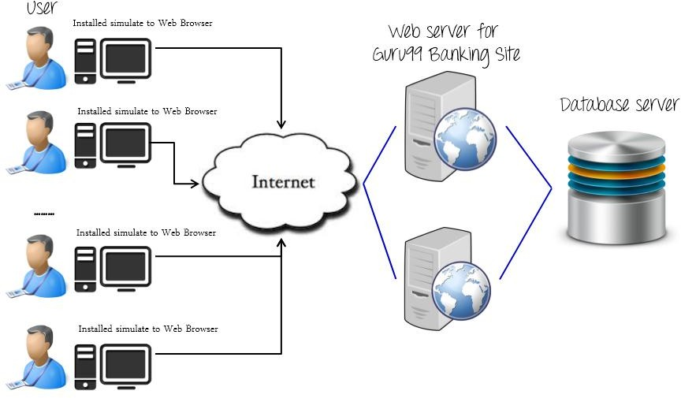



# SCHEDULE & ESTIMATION

## All project task and estimation

|  |  |  |
| --- | --- | --- |
| **Task** | **Members** | **Estimate effort** |
| **Create the test specification** | Test Designer | 170 man-hours |
| **Perform Test Execution** | Tester, Test Administrator | 80 man-hours |
| **Test Report** | Tester | 10 man-hours |
| **Test Delivery** |  | 20 man-hour |
| **Total** |  | **280 man-hours** |

# TEST DELIVERABLES

Test deliverables are provided as below

## Before testing phase

* Test plans document.
* Test cases documents
* Test Design specifications.

## During the testing

* Test Tool
* Simulators.
* Test Data
* Test Trace-ability Matrix
* Error logs and execution logs.

## After the testing cycles is over

* **Test Results/reports**
* Defect Report
* Installation/ Test procedures guidelines

## Release notes